**Week 2**

**JUnit Testing Exercises**

**Exercise 1: Setting Up JUnit**

Scenario: You need to set up JUnit in your Java project to start writing unit tests.

**FILE STRUCTURE**

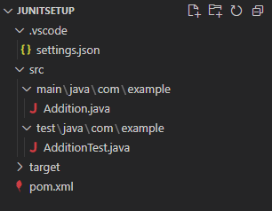

**CODE**

*src\main\java\com\example\Addition.java*

package com.example;

public class Addition {

    public int add(int a, int b) {

        return a + b;

    }

}

*src\test\java\com\example\AdditionTest.java*

package com.example;

import org.junit.Test;

import static org.junit.Assert.*;

public class AdditionTest {

    @Test

    public void testAdd() {

        Addition calc = new Addition();

        assertEquals(5, calc.add(2, 3));

    }

}

*pom.xml*

<project xmlns="http://maven.apache.org/POM/4.0.0"

         xmlns:xsi="http://www.w3.org/2001/XMLSchema-instance"

         xsi:schemaLocation="http://maven.apache.org/POM/4.0.0

         http://maven.apache.org/xsd/maven-4.0.0.xsd">

    <modelVersion>4.0.0</modelVersion>

    <groupId>com.example</groupId>

    <artifactId>JUnitMavenManual</artifactId>

    <version>1.0-SNAPSHOT</version>

    <dependencies>

        <dependency>

            <groupId>junit</groupId>

            <artifactId>junit</artifactId>

            <version>4.13.2</version>

            <scope>test</scope>

        </dependency>

    </dependencies>

    <build>

        <sourceDirectory>src/main/java</sourceDirectory>

        <testSourceDirectory>src/test/java</testSourceDirectory>

    </build>

</project>

*.vscode\settings.json*

{

  "java.project.sourcePaths": ["src/main/java"],

  "java.project.testSourcePaths": ["src/test/java"]

}

**OUTPUT**

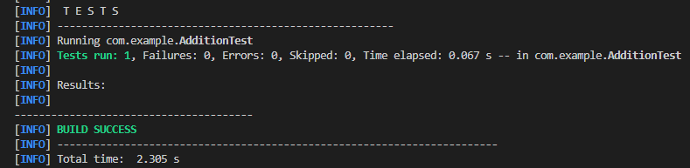

**Exercise 3: Assertions in Junit**

Scenario: You need to use different assertions in JUnit to validate your test results**.**

**FILE STRUCTURE**

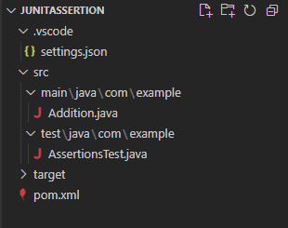

**CODE**

*src\main\java\com\example\Addition.java*

package com.example;

public class Addition {

    public int add(int a, int b) {

        return a + b;

    }

}

*src\test\java\com\example\AssertionsTest.java*

package com.example;

import org.junit.Test;

import static org.junit.Assert.*;

public class AssertionsTest {

    @Test

    public void testAssertions() {

        // Assert equals

        assertEquals(5, 2 + 3);

        // Assert true

        assertTrue(5 > 3);

        // Assert false

        assertFalse(5 < 3);

        // Assert null

        assertNull(null);

        // Assert not null

        assertNotNull(new Object());

    }

}

*pom.xml*

<project xmlns="http://maven.apache.org/POM/4.0.0"

         xmlns:xsi="http://www.w3.org/2001/XMLSchema-instance"

         xsi:schemaLocation="http://maven.apache.org/POM/4.0.0

         http://maven.apache.org/xsd/maven-4.0.0.xsd">

    <modelVersion>4.0.0</modelVersion>

    <groupId>com.example</groupId>

    <artifactId>JUnitMavenManual</artifactId>

    <version>1.0-SNAPSHOT</version>

    <dependencies>

        <dependency>

            <groupId>junit</groupId>

            <artifactId>junit</artifactId>

            <version>4.13.2</version>

            <scope>test</scope>

        </dependency>

    </dependencies>

    <build>

        <sourceDirectory>src/main/java</sourceDirectory>

        <testSourceDirectory>src/test/java</testSourceDirectory>

    </build>

</project>

.*vscode\settings.json*

{

  "java.project.sourcePaths": ["src/main/java"],

  "java.project.testSourcePaths": ["src/test/java"]

}

**OUTPUT**

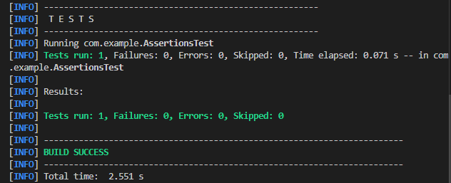

**Exercise 4: Arrange-Act-Assert (AAA) Pattern, Test Fixtures, Setup and Teardown Methods in JUnit**

Scenario: You need to organize your tests using the Arrange-Act-Assert (AAA) pattern and use setup and teardown methods.

**FILE STRUCTURE**

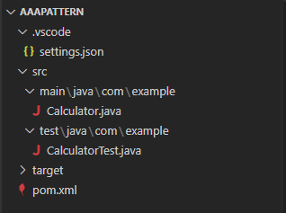

**CODE**

*src\main\java\com\example\Calculator.java*

package com.example;

public class Calculator {

    public int add(int a, int b) {

        return a + b;

    }

    public int subtract(int a, int b) {

        return a - b;

    }

    public int multiply(int a, int b) {

        return a * b;

    }

    public float divide(float a, float b) {

        return a / b;

    }

}

*src\test\java\com\example\CalculatorTest.java*

package com.example;

import org.junit.After;

import org.junit.Before;

import org.junit.Test;

import static org.junit.Assert.*;

public class CalculatorTest {

    private Calculator calculator;

    // Setup method - runs before each test

    @Before

    public void setUp() {

        calculator = new Calculator();

        System.out.println("Setup complete");

    }

    @After

    public void tearDown() {

        calculator = null;

        System.out.println("Teardown complete");

    }

    // Test using AAA pattern for addition

    @Test

    public void testAdd() {

        // Arrange

        int a = 10;

        int b = 5;

        // Act

        int result = calculator.add(a, b);

        // Assert

        assertEquals(15, result);

    }

    // Test using AAA pattern for subtraction

    @Test

    public void testSubtract() {

        // Arrange

        int a = 10;

        int b = 3;

        // Act

        int result = calculator.subtract(a, b);

        // Assert

        assertEquals(7, result);

    }

    // Test using AAA pattern for multiplication

    @Test

    public void testMultiply() {

        //Arrange

        int a = 4;

        int b = 5;

        //Act

        int result = calculator.multiply(a, b);

        //Assert

        assertEquals(20, result);

    }

    // Test using AAA pattern for division

    @Test

    public void testDivide() {

        //Arrange

        float a = 10;

        float b = 5;

        //Act

        float result = calculator.divide(a, b);

        //Assert

        assertEquals(2.0f, result, 0.0001f);

    }

}

*pom.xml*

<project xmlns="http://maven.apache.org/POM/4.0.0"

         xmlns:xsi="http://www.w3.org/2001/XMLSchema-instance"

         xsi:schemaLocation="http://maven.apache.org/POM/4.0.0

         http://maven.apache.org/xsd/maven-4.0.0.xsd">

    <modelVersion>4.0.0</modelVersion>

    <groupId>com.example</groupId>

    <artifactId>JUnitMavenManual</artifactId>

    <version>1.0-SNAPSHOT</version>

    <dependencies>

        <dependency>

            <groupId>junit</groupId>

            <artifactId>junit</artifactId>

            <version>4.13.2</version>

            <scope>test</scope>

        </dependency>

    </dependencies>

    <build>

        <sourceDirectory>src/main/java</sourceDirectory>

        <testSourceDirectory>src/test/java</testSourceDirectory>

    </build>

</project>

*.vscode\settings.json*

{

  "java.project.sourcePaths": ["src/main/java"],

  "java.project.testSourcePaths": ["src/test/java"]

}

**OUTPUT**

